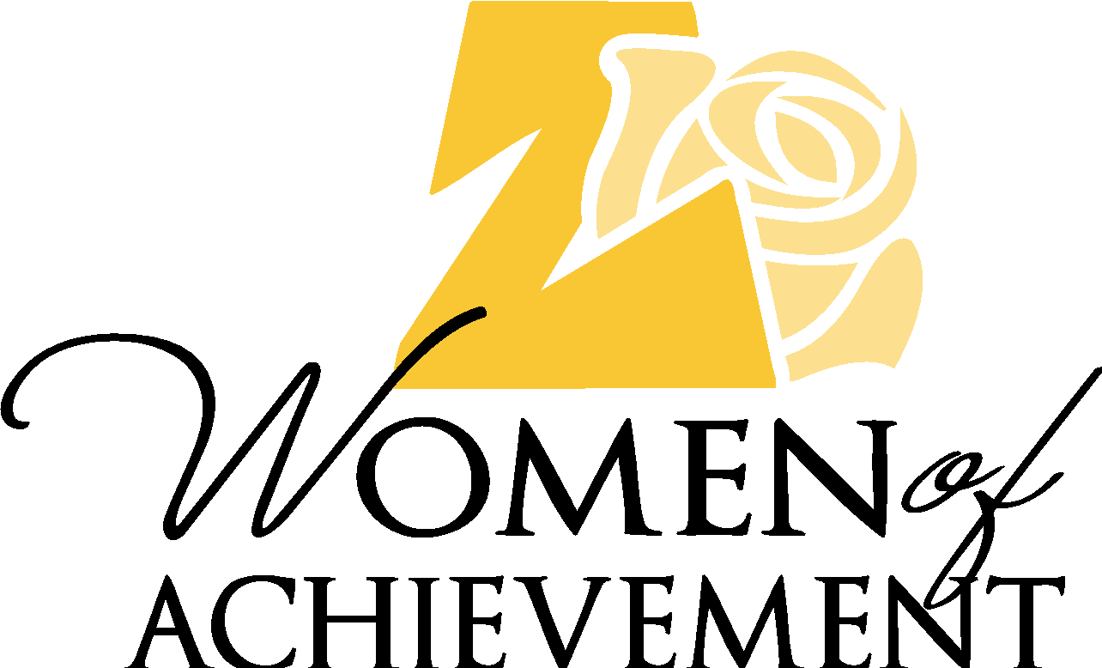
ZONTA EXPO SPONSOR
(The Expo is for Women-Owned Businesses to Highlight and Support Women in Business)
Capitol Plaza Hotel - Thursday, May 23, 2024
9:30 am to 11:30 am (Hotel Atrium)

Set Up (8:00 a.m. – 9:30 a.m.) Expo Opens at 9:30 a.m., Luncheon 11:30 a.m. – 1:30 p.m.

$100 - EXCLUSIVE VENDOR BOOTH SPONSOR
- 2 lunch tickets provided per booth
- Security for booths will be provided during the Luncheon
- Booth Space (6' x 10')
- Company name presented in the following: News Tribune Insert, Luncheon Program & Slide Show Presentation
- Social Media Posts/Mentions (Posted by Zonta Club of JC)

*Registration deadline is March 31, 2024
*Proceeds support Zonta's Second Chance Scholarship Fund

Women-Owned Business Expo Sponsor Registration

Expo Sponsor Information:

____ Please check here to confirm this business is a woman-owned business.

Name of Woman Owner: ____________________________________________________________________

Primary Contact (if different than Woman Owner): _______________________________________________

Business Name (As it should appear in all advertisement): __________________________________________

Business Mailing Address: ____________________________________________________________________

Business Phone #: (______ ) ______ - ________ Email:____________________________________________

Primary Contact Phone #: (______ ) ______ - ________ Email:______________________________________

Electricity needed at Booth? ___Yes ___ No

Complete this form and return, along with your check made payable to:

Zonta Club of Jefferson City Foundation
Attn: Expo
P.O. Box 106021
Jefferson City, MO 65110

*For assistance or questions contact: Becky Miller – Expo Chair - (573) 230-5527
E-mail: bmiller0509@gmail.com

